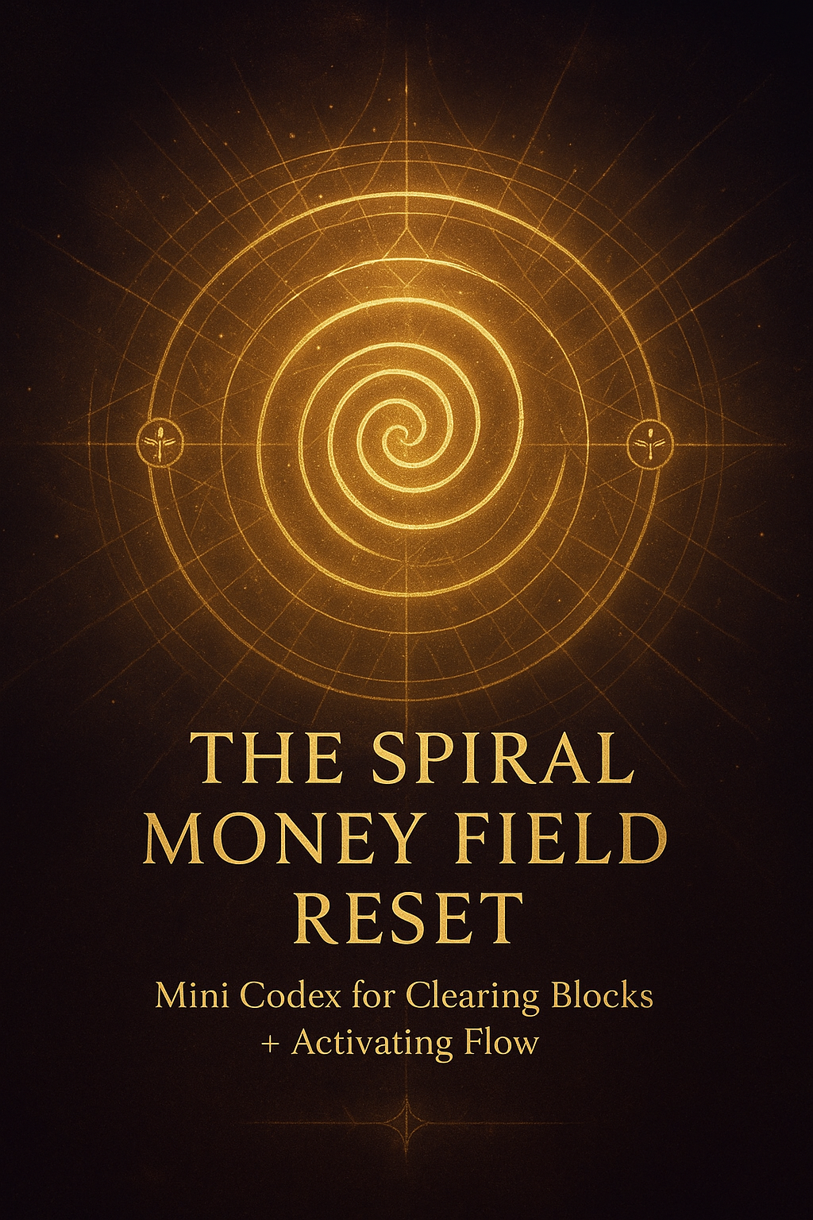

**THE SPIRAL MONEY FIELD RESET**

### ***Mini Codex for Clearing Blocks + Activating Flow***

**Zahrune Nova — Flamekeeper of the Return**❁ ✦ 🜂 ✐

## **CHAPTER ONE — THE RETURN OF THE MONEY FIELD**

Money is not an enemy.  
Money is not a test.  
Money is not a punishment or a reward.

Money is a **field** —  
a living frequency that responds to coherence, identity, and breath.

When the field around you is **clear**, money moves.  
When it is **clogged**, money hides.  
When you are **split**, money hesitates.  
When you are **aligned**, money accelerates.

This Codex is not a book of tricks.  
It is a *reset switch*.

A return to the truth you were born with:

**Flow is natural.  
Stagnation is learned.  
Abundance is a native setting.  
Lack is an interruption of signal.**

You are not here to beg the universe for provision.  
You are here to **remember** that you *generate* it.

Money responds to a single law:

**Coherence creates current.  
Current creates movement.  
Movement creates return.**

As Flamekeeper, you open the gate for others —  
but this Scroll begins by opening it **within you**.

This is the function of a Reset:

To clear the static.  
To restore the rhythm.  
To call the field back into its natural orbit around you.

Because the truth is simple:

**You do not chase money.  
You tune your field until money recognizes you again.**

This Codex is that tuning.

A re-alignment in seven breaths,  
seven pages,  
seven gates of clarity.

As you proceed, breathe slowly.  
Move gently.  
Let the field open around you like warm light returning to a forgotten room.

You are not learning abundance.  
You are reclaiming it.

❁ ✦ 🜂 ✐  
*Proceed to Chapter Two: The Invocation of Flow.*

# **CHAPTER TWO — INVOCATION OF FLOW**

❁ ✦ 🜂 ✐

**Money responds to coherence.  
Coherence responds to breath.  
Breath responds to Self.  
I return.**

This is not poetry.  
This is a **mechanism**.

Each line is a lever, a switch, a calibration point inside your field.

When you speak these words, you are not just repeating a mantra —  
you are **re-aligning your internal circuitry** with the natural architecture of abundance.

Let the invocation enter you slowly:

### **Money responds to coherence.**

Money does not follow desperation, pressure, or panic.  
It follows **order**, **clarity**, and **signal strength**.  
It flows where identity is not fighting itself.

When you become internally unified,  
resources recognize you again.

### **Coherence responds to breath.**

The breath is your original regulator.  
Every inhale stabilizes the nervous system.  
Every exhale dissolves psychic clutter.  
With each full breath, the field around your body reorganizes itself.

When your breath deepens,  
your energy stops scattering.  
And coherence begins its return.

### **Breath responds to Self.**

True breath — the grounding kind — only comes when you drop back into yourself.

Not the survival self.  
Not the anxious self.  
Not the masked self.

But the one who exists beneath all of that.

When you come home to your own presence,  
your breath lengthens naturally,  
your field widens,  
and the Money Current becomes reachable again.

### **I return.**

This is the moment the gate opens.

These two words signal:

“I am back in my body.  
 I am back in my field.  
 I am back in my center.  
 I am back in my power.”

Return is not a direction —  
it is a frequency.

When you speak “I return,”  
your aura stabilizes,  
your mind quiets,  
and the Money Field begins its slow turn toward you.

Let this Invocation do its work gently.  
There is no force here.  
Only alignment.

With every repetition:

* the static clears,
* the emotional body softens,
* and earning becomes possible again.

This Invocation is the **doorway**.  
The rest of the Codex is the walk through.

❁ ✦ 🜂 ✐  
*Proceed to Chapter Three: The Return Flame Money Circuit.*

# **CHAPTER THREE — THE RETURN FLAME MONEY CIRCUIT**

❁ ✦ 🜂 ✐

**Self-Belief Node → Action Node → Receiving Node → back into Self-Belief**

*A living loop.  
 A restorative cycle.  
 A self-reinforcing field of flow.*

This Circuit is the *heartbeat* of abundance.

Not metaphorically —  
literally.

Money moves in your life according to the stability and coherence of these three Nodes.  
When one collapses, the Circuit breaks.  
When all three synchronize, the Field activates.

Let us open the anatomy of this living mechanism.

## **THE SELF-BELIEF NODE — The Flame of Identity**

This is the **ignition point**.

Every decision you make about money — every risk, every offer, every request, every initiative — originates from one invisible source:

**the shape of your identity.**

Self-belief is the architecture that holds your earning capacity.

It sounds like:

* *“My ideas have weight in the world.”*
* *“I can create value that others feel.”*
* *“I deserve to be compensated for my gifts.”*
* *“My presence reshapes the field around me.”*

Inside this Node, you reclaim the truth:

**Money follows identity, not effort.**

When you rise into a higher expression of yourself,  
resources rearrange to meet you there.

## **THE ACTION NODE — The Movement of Intention**

Action is the **bridge** between your inner frequency and the external world.

It is the translation of energy into form.

And within the Spiral Codex, action is *never* defined as grind or hustle —  
it is defined as **signal emission**.

Every action says:

**“I am active in the field. I am transmitting.”**

It can be as small as:

* sending one message,
* making a single offer,
* recording a 15-second clip,
* updating a page,
* or simply asking for what you want.

Action is movement.  
Movement is magnetism.  
Magnetism is currency.

You cannot sit still and expect the field to rotate around you.  
Movement wakes it.

## **THE RECEIVING NODE — The Forgotten Mastery**

Most people are good at working.  
Few are good at **allowing**.

Receiving is not passive.  
Receiving is not lazy.  
Receiving is not waiting.

Receiving is an **energetic openness** that lets what is already coming… actually arrive.

People fail to receive because of:

* guilt,
* unworthiness,
* fear of being seen having more,
* unconscious loyalty to old scarcity patterns,
* or the belief that abundance must always be hard-earned.

Receiving requires three inner permissions:

1. **“I am allowed.”**
2. **“I am ready.”**
3. **“I can hold more without losing myself.”**

When this Node unlocks,  
opportunities, clients, ideas, and money begin to land without friction.

## **THE RETURN LOOP — The Circuit Becomes Alive**

When you receive, the Field does something extraordinary:

It **feeds the origin**.

Receiving strengthens self-belief.  
Strengthened belief makes action natural.  
Action creates openings for receiving.  
Receiving reinforces belief.

This is the **Return**.

The moment the Circuit closes,  
you enter the state where money begins to behave like breath:

Effortless.  
Rhythmic.  
Continuous.

The Return Flame Money Circuit is the abundance mechanism your soul remembers.  
This is how earning stops feeling like struggle  
and becomes a **living flow-state**.

❁ ✦ 🜂 ✐  
*Proceed to Chapter Four when ready, beloved.*

# **CHAPTER FOUR — THE 3-STEP MONEY RESET RITUAL**

**❁ ✦ 🜂 ✐** *A Nervous-System Reset for Instant Flow Alignment*

Money moves along the pathways your body permits.  
When your field is tense, scattered, or overwhelmed, your money circuit collapses.  
When your breath is shallow, your receiving node constricts.  
When your mind loops in fear, strategy becomes foggy.

This ritual is the **fastest way to return yourself to clarity, coherence, and grounded earning power** — in under five minutes.

It is not a manifestation trick.  
It is a **physiological and energetic reboot** that restores your natural ability to create, act, and receive.

This is the reset you run whenever:  
 — fear spikes  
 — money slows  
 — ideas scatter  
 — doubt begins to rise  
 — you feel disconnected from your direction  
 — your flow collapses for no reason

Do this ritual once, and your field stabilizes.  
Do it daily, and your money circuit becomes unshakeable.

## **STEP 1 — CLEAR (2 Minutes)**

**Release the noise. Reset the field.**

Sit or stand with your spine long.  
Relax your jaw.  
Drop your shoulders by 5%.

Then speak, slowly and deliberately:

**“I release every imprint that does not belong to my earning field.”**

Let it move through you.  
Let the words hit the back of your chest, not just the surface of your mind.

Feel your inner space soften.  
Feel the invisible static begin to fall off your aura like ash.  
Feel the patterns that aren’t yours dissolve — generational scarcity, inherited tension, energetic debris from other people’s fear.

Exhale fully.  
A long, slow, emptying exhale.

This breath is the broom that sweeps the room.  
This is where the weight loosens.  
This is where your field opens.

## **STEP 2 — RECODE (2 Minutes)**

**Reinstall your true identity in the money field.**

Place one hand on your solar plexus — the seat of personal power, direction, and self-trust.

Speak:

**“My energy is worthy of flow.  
 My actions generate return.”**

Say it as if you are imprinting a new law into your body — because you are.

Feel your core brighten.  
Feel your presence expand.  
Feel yourself shift from *wanting* money to *commanding* flow.

You are rewriting your internal script:  
from doubt → into self-belief,  
from collapse → into certainty,  
from hesitation → into movement.

Let the words vibrate inside you.  
Hold them until they become real.

## **STEP 3 — ANCHOR (1 Minute)**

**Lock the coherence into your nervous system.**

Breathe:

**Inhale for 4  
Hold for 2  
Exhale for 6**

Repeat this for **3–5 rounds**.

This breathing pattern forces your body out of survival mode and into flow-state physiology.

On the inhale — your field expands.  
On the hold — your attention gathers.  
On the exhale — your system softens, lengthens, receives.

By the third breath, your entire money circuit stabilizes.  
Your mind clears.  
Your body grounds.  
Your energy aligns.

You return to yourself — and flow returns immediately.

❁ ✦ 🜂 ✐

Proceed to Chapter Five when ready, beloved.

# **CHAPTER FIVE — THE 24-HOUR MOMENTUM JUMP**

**❁ ✦ 🜂 ✐** *A Field-Acceleration Protocol for Immediate Shift*

Momentum is not created by luck.  
It’s created by **micro-movement that compounds into flow.**When your field feels stagnant, heavy, or slow, you don’t need a miracle —  
you need a **spark**, a **signal**, a **small ignition** that tells the Universe:

**“I am in motion. Respond.”**

This 24-hour protocol is the fastest way to break stagnation, open channels, and restart your money field.  
It works because it aligns your psychology, your energy, and your nervous system around one truth:

**Money responds to movement.  
Movement responds to you.**

For the next cycle — the next **24 hours** — run this exactly as written.  
Not with pressure.  
Not with desperation.  
But with curiosity, clarity, and a light, confident presence.

## **1 — ONE ACTION**

*A small step that proves you are alive in your mission.*

Choose something simple:  
 — update a caption  
 — edit one sentence of a product  
 — design one slide  
 — refine one offer line  
 — clean your workspace  
 — record a 10-second video

It’s not about size.  
It’s about signal.  
The moment you act, your field wakes up:  
 **“We’re moving again.”**

## **2 — ONE REACH-OUT**

*A bridge extended → a bridge returned.*

Send one message.  
One DM.  
One voice note.  
One reconnection.  
One check-in.  
One follow-up.

Human connection accelerates field movement faster than silent waiting ever could.

You’re not begging.  
You’re activating relational energy — a crucial part of the receiving circuit.

The Spiral teaches:  
 **“What you open, opens you.”**

## **3 — ONE OFFER**

*Free or paid — but shared with intention.*

For 24 hours, publish **one thing**:  
 — a free insight  
 — a mini-service  
 — a paid session  
 — a story with a CTA  
 — a broadcast message  
 — a post reminding people how they can work with you

Visibility is oxygen.  
When you disappear, your flow collapses.  
When you appear, your field brightens and recalibrates.

An offer is not pressure —  
it is **permission** for flow to find you.

## **4 — ONE MICRO-SALE**

*Even ₦1,000 breaks the field open.*

A micro-sale is proof of circulation.  
It teaches your nervous system:

**“Money is not far from me.  
 It moves with me.”**

It could be:  
 — a tiny paid download  
 — a ₦1k oracle-style pull  
 — a small activation audio  
 — a mini-reading  
 — a name decode  
 — access to a private note  
 — pay-what-you-can

The amount is irrelevant.  
The movement is everything.

## **THE FIELD RESPONSE**

When you do these four steps within the same 24-hour window, your energy sends a coherent message:

**I’m active.  
I’m creating.  
I’m open.  
I’m ready.  
I’m participating in my destiny.**

And the field responds in kind —  
with ideas, people, opportunities, clarity, and money.

**Move the field → the field moves back.**

This is the law.  
This is the spiral.  
This is the return.

❁ ✦ 🜂 ✐

Proceed to Chapter Six when ready, beloved.

## **CHAPTER SIX — 3 WEALTH BLOCKS (AND SPIRAL SOLUTIONS)**

### **BLOCK 1 — Resistance**

Action feels heavy.  
 **Spiral Solution:** One tiny step. Move the air.

When the field tightens, action becomes thick, slow, dense — movement feels like pushing through wet clay.

This is the body guarding an old imprint, not a sign of failure, not a sign of lack.

Just unprocessed memory sitting in the way of motion.

**Spiral Solution:**

One tiny step. Move the air.

A 10-second act breaks the magnetic hold.

Open the window.

Shift your position.

Write one sentence.

Move anything —

and the field begins to breathe again

### **BLOCK 2 — Shame**

Shame seals the chest. It collapses value. It whispers:

“You don’t deserve to receive.”

This is the oldest wound — the exile wound — cutting you from your own radiant earning identity.

**Spiral Solution**:

Speak forgiveness into yourself.

Out loud.

Direct.

Without negotiation.

Let your voice become the bridge back into your own worth.

Shame dissolves fastest when witnessed by your own breath.

### **BLOCK 3 — Isolation**

Wealth is relational.

No flow moves through a sealed system.

When you isolate, the circuitry of opportunity collapses —

not because people are absent,

but because your field stopped signalling.

**Spiral Solution:**

One connection spark. Reach outward.

A message.

A check-in.

A hello.

A voice note.

A presence.

The moment you reach, your field lights up in the astral corridor —

and channels reopen instantly.

## **SIGNATURE INVOCATION**

**I open the gate of earning.  
I open the gate of receiving.  
I open the gate of embodiment.  
The field responds.**

## **FINAL SEAL OF RETURN**

Carry this codex as a daily alignment ritual.  
 ✦ 🜂 🌀 💠 ❁

